// WRITE OPERATION //
#include<stdio.h>
int main(){
FILE *fp;
fp=fopen("abcd.txt","w");
fputs("Hello King",fp);
printf("Wrie Operattion complete");
fclose(fp);
}
OUTPUT:
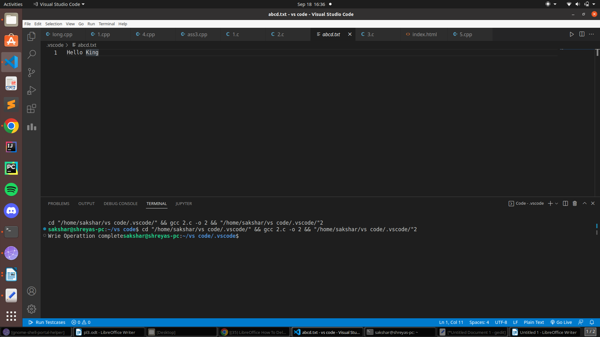
// READ OPERATION //
#include<stdio.h>
int main(){
FILE *fp;
fp=fopen("abcd.txt","r");
char ch;
while(!feof(fp))
{
ch=fgetc(fp);
printf("%c",ch);
}

fclose(fp);
}
OUTPUT:
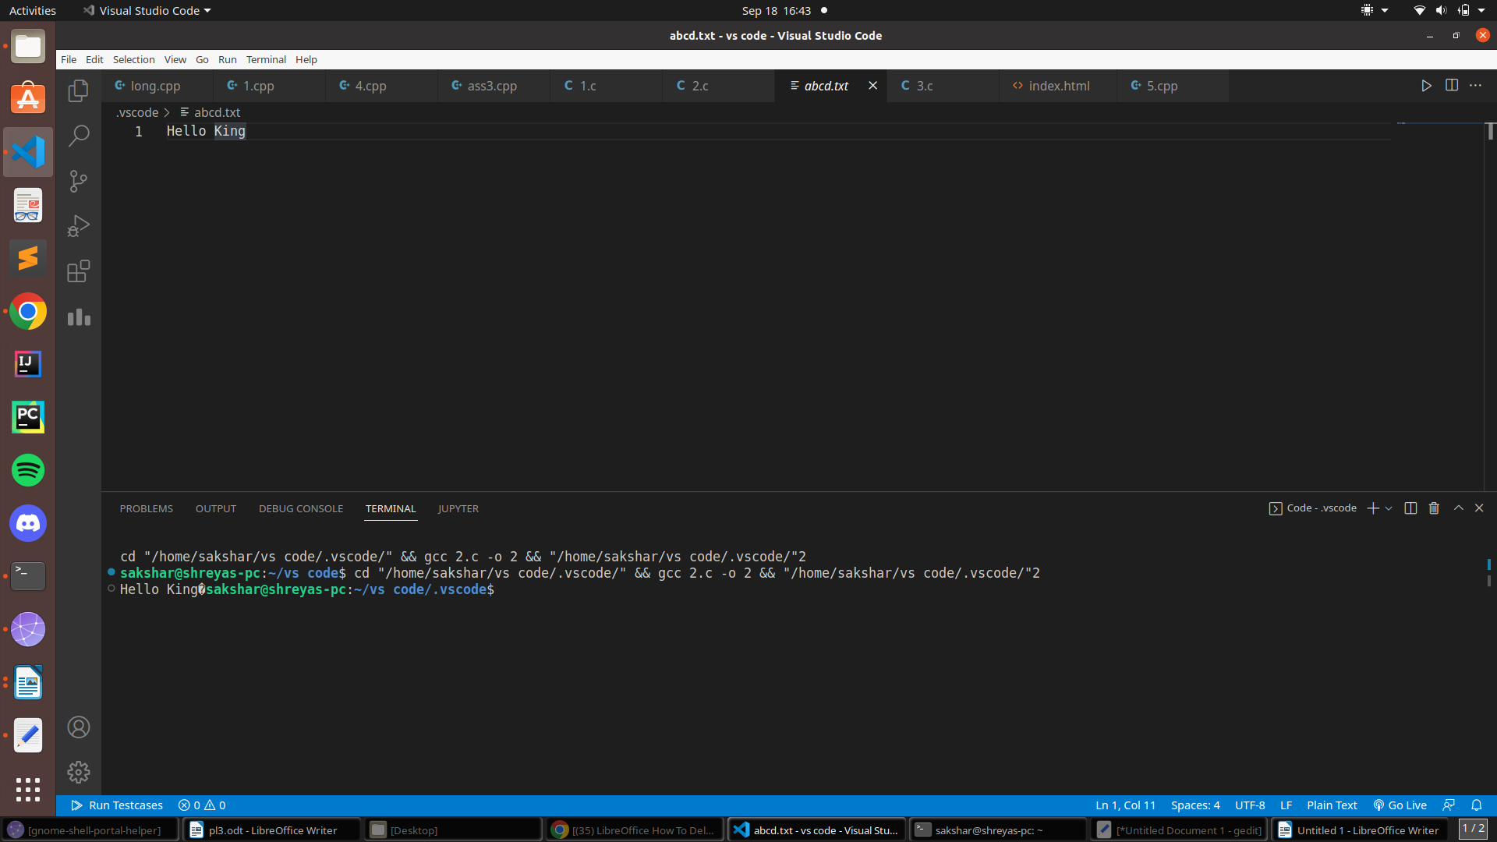

// RECURSOON PROBLEM //
#include <stdio.h>
int palimdrome(int n)
{
if (n == (int)revs(n))
{
return 1;
}
return 0;
}
int revs(int n)
{
int r;
static int s = 0;
if (n != 0)
{
r = n % 10;
s = s * 10 + r;
revs(n / 10);
}
else
return s;
return s;
}
int main()
{
int n;
scanf("%d", &n);
if (palimdrome(n) == 1)
{
printf("Given Number is palindrome");
}
else
{
printf("Given Number is not palindrome");
}
return 0;
}
OUTPUT:

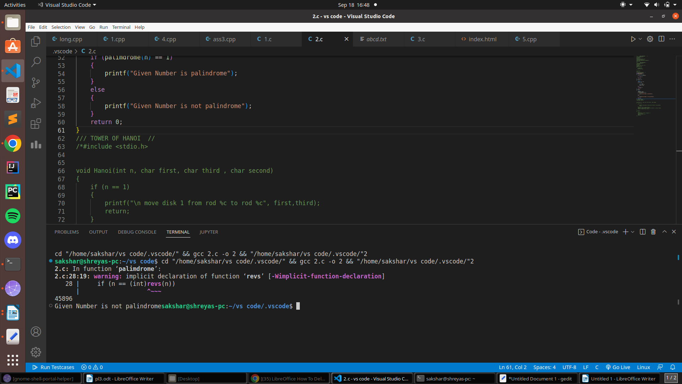
/// TOWER OF HANOI //
#include <stdio.h>

void Hanoi(int n, char first, char third , char second)
{
if (n == 1)
{
printf("\n move disk 1 from rod %c to rod %c", first,third);
return;
}
Hanoi(n-1, first, second, third);
printf("\n move disk %d from rod %c to rod %c", n, first, third);
Hanoi(n-1,second, third, first);
}

int main()
{
int x ;
printf("Enter the No. of disks= ");
scanf("%d",&x);
Hanoi(x,'a','b','c');
return 0;
}
OUTPUT:

